**TIOBE Index** is an index (ranking) that claims to represent the popularity of programming languages. [Yihui](https://yihui.name/en/about/) (The creator of blogdown package), recently wrote a blogpost titled “[On TIOBE Index and the era of decision fatigue](https://yihui.name/en/2019/06/tiobe-index/)” and I strongly recommend you to go through that before continuing with this post.

So the **Disclaimer** goes like this: *This post/author doesn’t believe that TIOBE Index is a fair way to measure/present popularity of programming languages and this is writtet just to teach you how to extract/get TIOBE Index programmatically using the R package tiobeindexr*

**tiobeindexr – Intro, Installation & Loading**

tiobeindexr is an R package to extract TIOBE Index of the given month.

tiobeindexr is available on CRAN so you can install like below:

install.packages("tiobeindexr")

Once installed, it can be loaded like any other R package:

library(tiobeindexr)

## Downloading TIOBE Index Data using your Internet...

When tiobeindexr is loaded for the first time in the given session, it downloads the required data from the internet.

**Extract top 20 programming languages of the month**

TIOBE Index publishes the rank of programming languages every month (monthly-refresh). We can use the function top_20() to extract the top 20 programming languages of the month (that TIOBE has published)

top_20()

## Jul 2019 Jul 2018 Programming Language Ratings Change

## 1 1 1 Java 15.058% -1.08%

## 2 2 2 C 14.211% -0.45%

## 3 3 4 Python 9.260% +2.90%

## 4 4 3 C++ 6.705% -0.91%

## 5 5 6 C# 4.365% +0.57%

## 6 6 5 Visual Basic .NET 4.208% -0.04%

## 7 7 8 JavaScript 2.304% -0.53%

## 8 8 7 PHP 2.167% -0.67%

## 9 9 9 SQL 1.977% -0.36%

## 10 10 10 Objective-C 1.686% +0.23%

## 11 11 12 Ruby 1.636% +0.43%

## 12 12 13 Assembly language 1.390% +0.24%

## 13 13 11 Swift 1.121% -0.29%

## 14 14 15 MATLAB 1.078% -0.05%

## 15 15 81 Groovy 1.070% +0.96%

## 16 16 18 Go 1.016% +0.05%

## 17 17 19 Visual Basic 1.009% +0.12%

## 18 18 16 Delphi/Object Pascal 0.950% -0.16%

## 19 19 17 Perl 0.918% -0.18%

## 20 20 14 R 0.837% -0.31%

**Visualising Top Changes of TIOBE Index This Month vs Previous Month**

As you can see in the output of the previous section, top_20() also gives us the % change MoM (Month-over-Month) which we can use to see the top changes.

For simplicity, We’ll load the entire tidyverse package and use ggplot2’s bar-plot to visualize the changes.

library(tidyverse)

top_20() %>%

mutate(Change = as.numeric(gsub('%','',Change))) %>%

ggplot(aes(x = reorder(`Programming Language`,Change), y = Change,

fill = `Programming Language`,

label = paste0(Change, "%"))) +

geom_col(show.legend = FALSE) +

coord_flip() +

geom_text(nudge_x = 0.1) +

xlab('Programming Language') +

ggtitle('Programming Languages Change this Month')

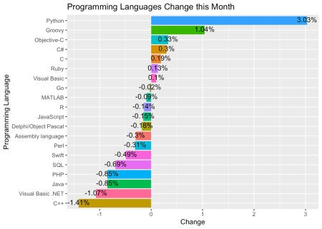

**Summary**

Hence, we learnt how to use tiobeindexr to programmatically download TIOBE Index and visualize insights from it. And, alongisde we also learnt that TIOBE Index in fact isn’t a fair represenation of the popularity of programming languages